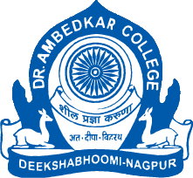

**PARAM POOJYA DR. BABASAHEB AMBEDKAR SMARAK SAMITI’S**

**DEPARTMENT OF LAW**

**NAAC REACCREDITED WITH ‘A’ GRADE**

**DEEKSHABHOOMI, NAGPUR** – 440010 **(M.S.)**

|  |  |
| --- | --- |
| **NAME OF THE PROGRAM** | **LECTURE ON CAREER OPPORTUNITIES** |
| **ORGANISING DEPARTMENT/ NAME THE CELL** | **NOUVEAU CORPORATE CLUB OF DEPARTMENT OF LAW** |
| **PROGRAM CO-ORDINATOR** | **DR. H.V. MENON**  **HOD OF LAW AND COMMITTEE CHAIR**  **DR. PRATIMA LOKHANDE**  **VICE CHAIR OF NC CLUB** |
| **DATE** | **29TH JULY 2024** |
| **RESOURCE PERSON** | **CS KHUSHAL BAJAJ**  **CHAIRMAN ICSI, NAGPUR CHAPTER** |
| **NUMBER OF STUDENTS** | **48** |

**NOTICE**

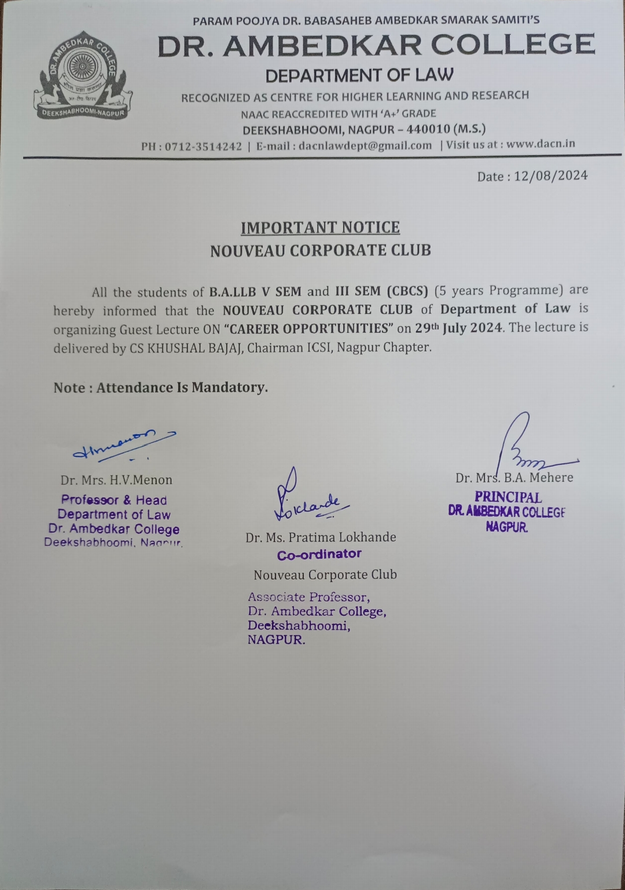

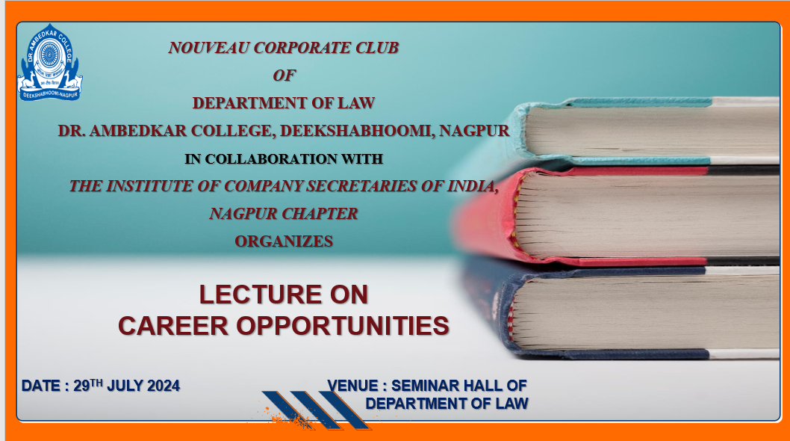

**REPORT**

Nouveau Corporates Club of Department of Law has organized lecture on, “**CAREER OPPORTUNITIES” on 29th July 2024**. The lecture was delivered by **CS KHUSHAL BAJAJ, Chairman ICSI, Nagpur Chapter.** The lecture aims to spread awareness among the students about the career opportunities of achieving the degree of Company Secretary from Institute of Company Secretaries of India (ICSI). This also helps the participants to understand the course structure, curriculum, syllabus, fee’s structure and time to get this course done. The program was organized in the Seminar room of the Department of law. After all the lectures and discussions there was question answer session between our participants and resource persons so that participants can be clarified about their quarries and ambiguities regarding this course. He briefly explained the significance of Company Secretary as a profession. Students found this special lecture as a useful one provided to them at the right time.

The programme was organized under the able guidance of Dr. H.V. Menon, Professor and Head of the Department of Law. Dr. Pratima Lokhande (Associate Professor and Vice Chair of the Nouveau Corporates Club, Department of Law DACN) worked for the successful completion of the program. The lecture was an altogether interactive session. Total 48 students have attended the program. The lecture was a great learning experience for the participants. Student member of NC Club Ms. Khushi Chavan has conducted the Program. It ended with formal vote of thanks.

**GLIMPSES OF THE EVENT**

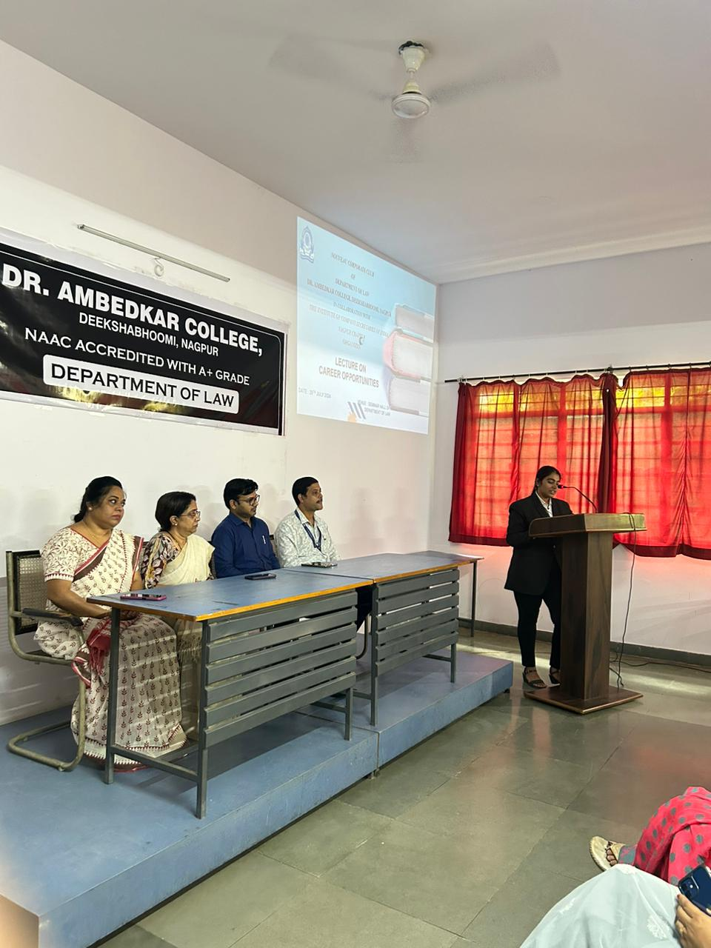

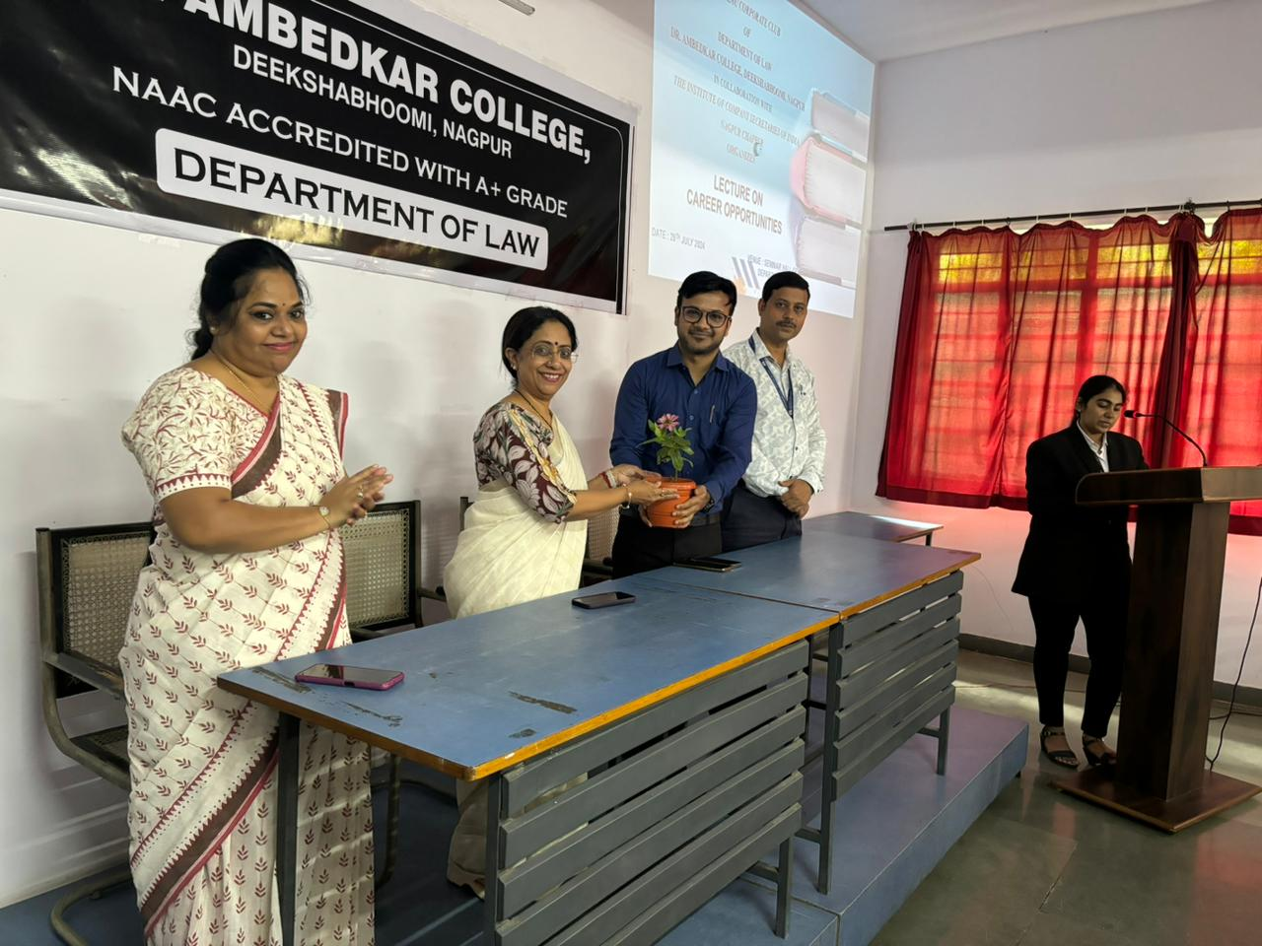 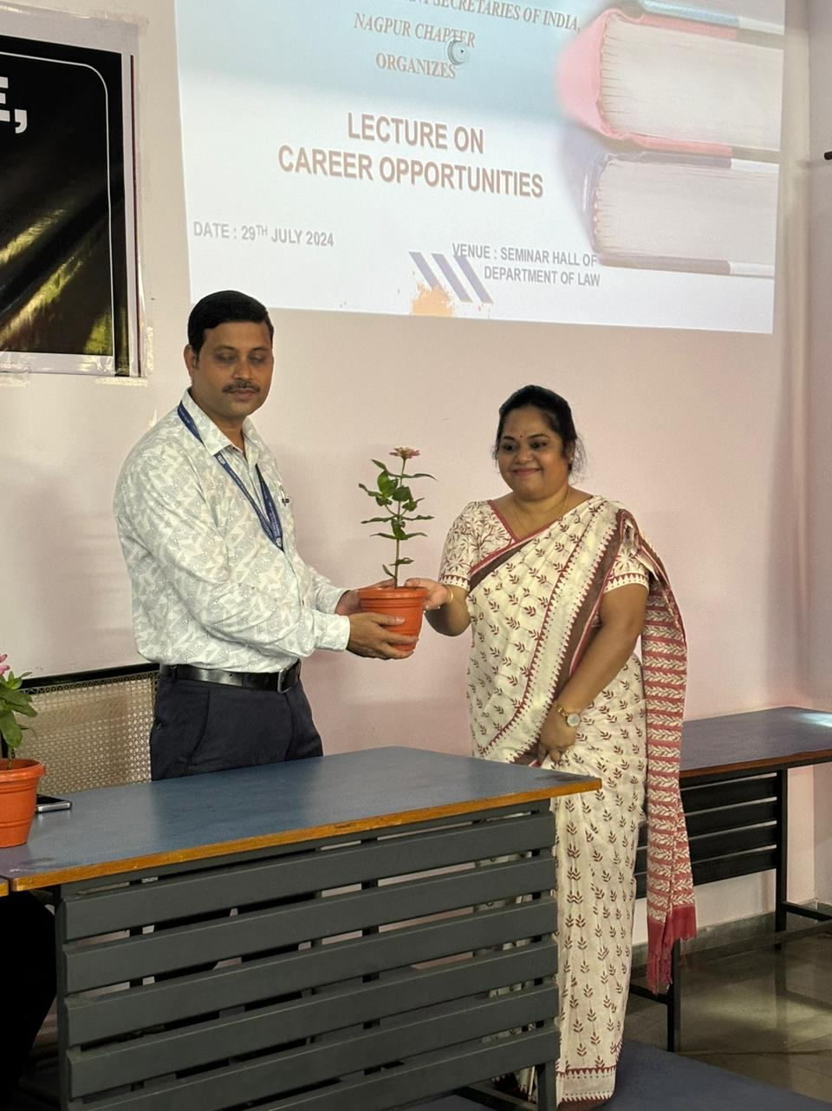

**Floral welcome of Guest speaker**

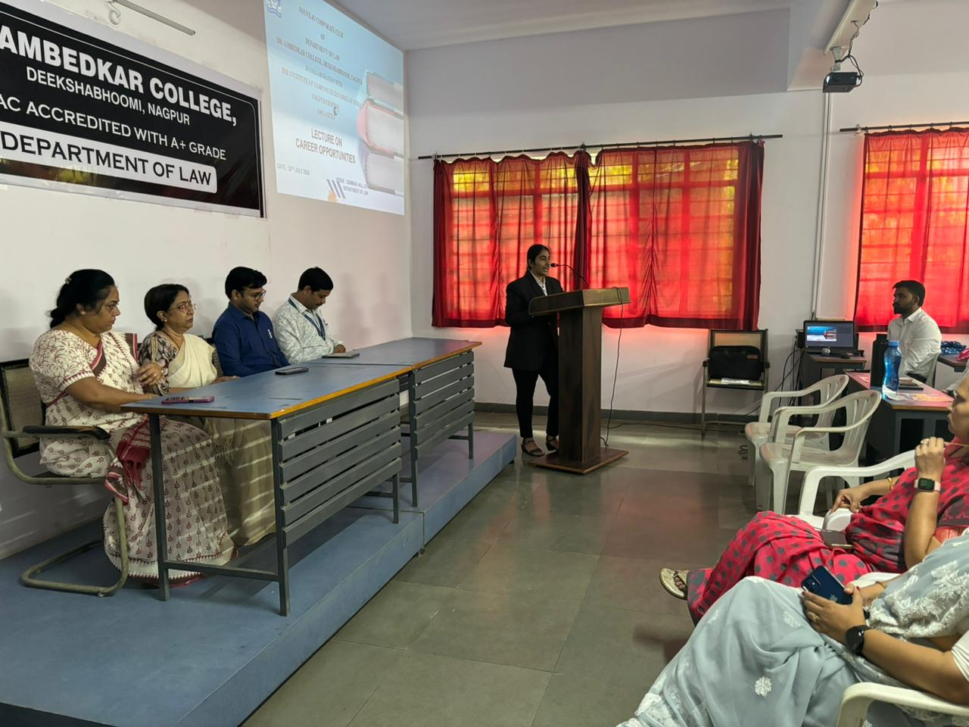

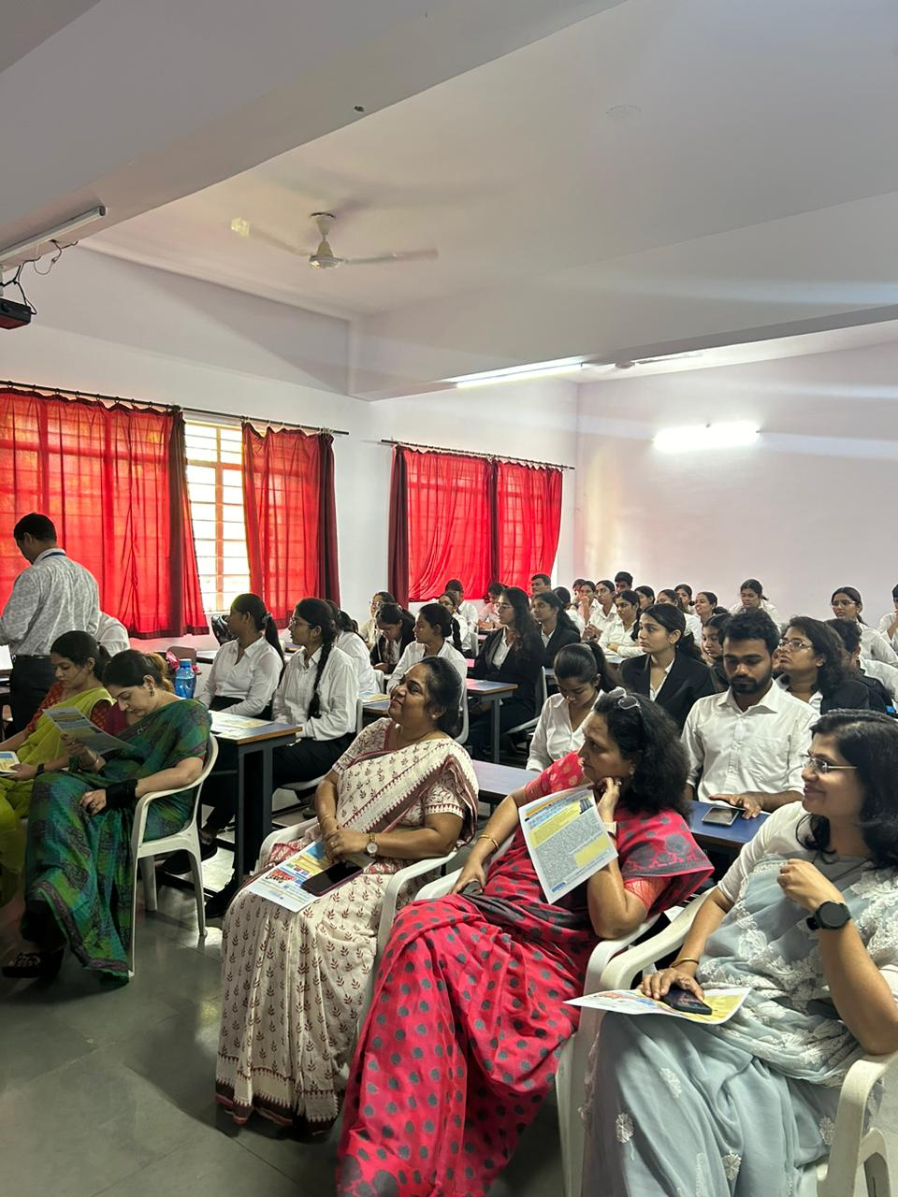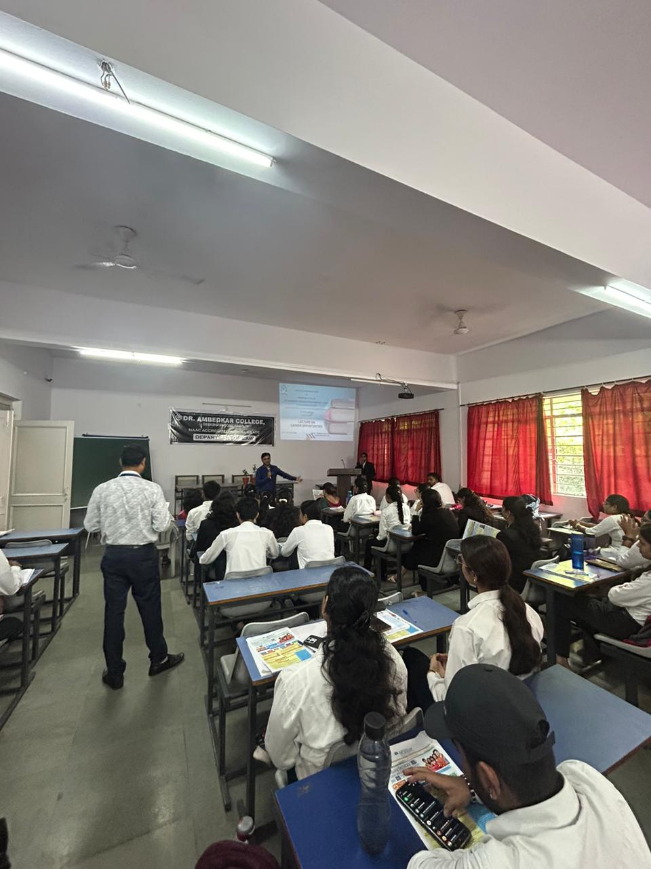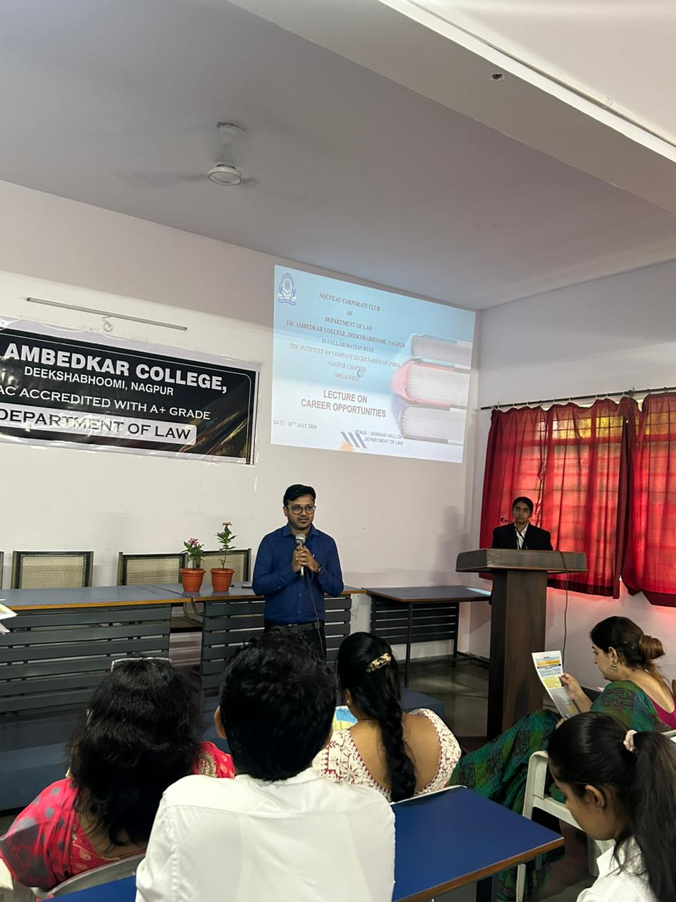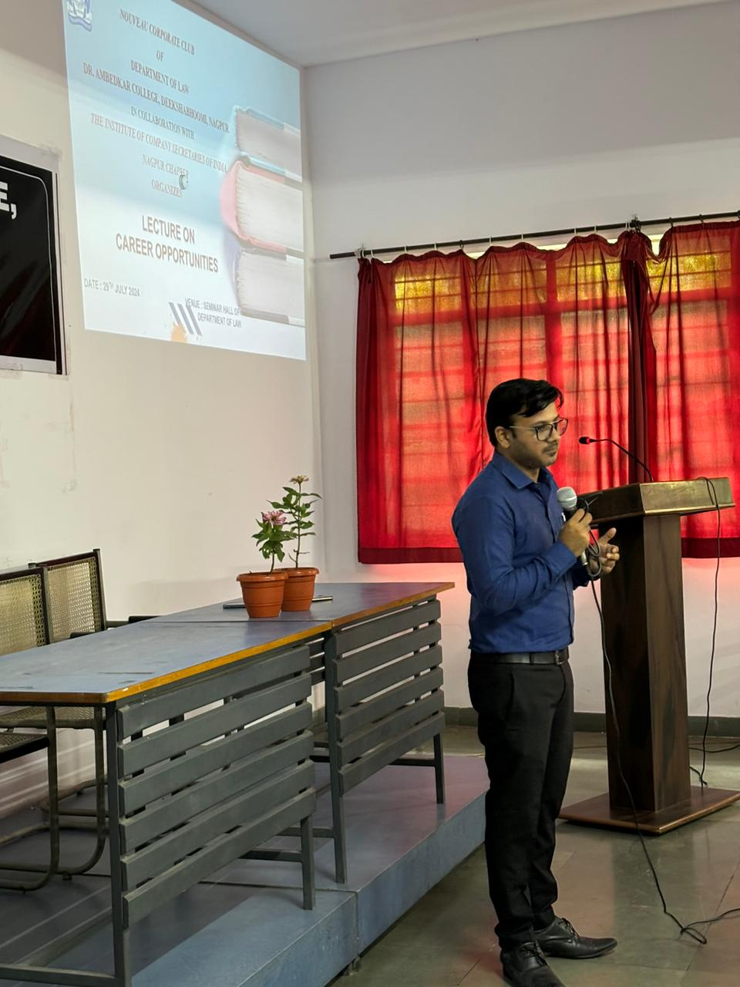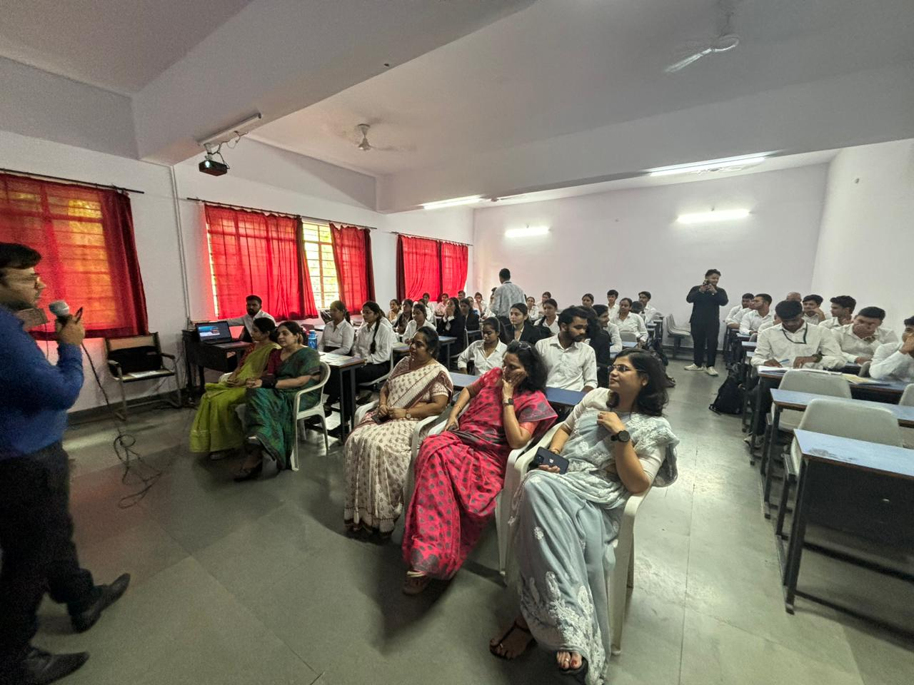

**Guest Speaker CS Khushal Bajaj addressing the students**

**Attendance List of the Students** 